Software Engineering Project

**Usability Evaluation Report (Tracing)**

**Smart-glass based**

**Remote Guidance System**

**Table 1. Document Change Control**

|  |  |  |  |
| --- | --- | --- | --- |
| **Version** | **Date** | **Authors** | **Summary of Changes** |
| 1.00 | 10/10/2018 | Dineth Gunawardena | Added Introduction, Participants, Procedure, Results, Discussion and Conclusion sections |

# Table of Contents

1) Introduction 3

2) Participants 3

3) Procedure 3

4) Results 4

4.1) Observations 4

4.2) Effectiveness 14

4.3) Efficiency 15

4.4) Satisfaction 16

5) Discussion 19

6) Conclusion 19

# Introduction

The usability evaluation held on the 4th of October from 4:30PM to 6:00PM in Library Group Room 1C. The aim of this usability evaluation is to test the usability of the tracing feature of the application we developed. The evaluation was conducted using the computers instead of the Smart Glasses due to the limited power and battery capacity of the Smart Glasses which wouldn’t allow us to record the evaluation for analyzing purposes. This report will analyze the results of 3 participants who participated in the Usability evaluation.

# 2) Participants

The participants that were chosen for the usability evaluation belonged of the target demographic that we see using the product. This was validated by the demographic questionnaires they filled out before the usability evaluation. We expect the target customers who are familiar with technology similar to smart phones to quickly adapt to the smart glasses and use the product with ease. All of our participants were university students who use smartphones daily.

# 3) Procedure

The participant would take the role of the instructor drawing the sketch on the snapshot, while a member of the team would act as the operator. The participant had to complete 3 tasks, incrementing the possible practicality of the tracing feature. The first task was to draw a simple line, the second task was to draw a shape and third task was to outline an object in the snapshot.  
While the evaluation was conducted, the supervisor was setting up the devices with each task, the facilitator was with the participant, and the observer was taking the records of the evaluation.

# 4) Results

The results of the evaluation were extracted from the observation sheets and satisfaction questionnaires for each participant.

## 4.1) Observations

|  |  |  |  |
| --- | --- | --- | --- |
| **Participant #1**  **Task #1** | Session Date:  04/10/2018 | Session Time:  4:30PM – 6:00PM | Supervisor: Lyndon Prado |
| Description: Tracing a simple line | | | |
| Completed (Y/N): | Y | | |
| Time spent on task: | 7 mins | | |
| No. of assists: | 0 | | |
| Action Sequence | | User Comments | Observer Comments |
| (1) | Draw a simple line with your finger | User claimed that the  app would be  Easier to use for left  Handed people. |  |
| General Comments | | | |
| The user was right handed and found it a bit difficult as he was asked to use his left hand to  Draw the trace. | | | |

|  |  |  |  |
| --- | --- | --- | --- |
| **Participant #1**  **Task #2** | Session Date:  04/10/2018 | Session Time:  4:30PM – 6:00PM | Supervisor: Lyndon Prado |
| Description: Tracing a shape | | | |
| Completed (Y/N): | Y | | |
| Time spent on task: | 10 mins | | |
| No. of assists: | 2 | | |
| Action Sequence | | User Comments | Observer Comments |
| (1) | Start drawing a simple trace |  |  |
| (2) | Complete the shape with the trace | User had trouble with  Drawing the trace as  The trace was inverted  To the movements of  His hand. | The movements are inverted  To work with the glasses |
| General Comments | | | |
| The issue faced by the user here wouldn’t be a problem as this is how the feature is supposed to be inverted with the smart glasses. 2 assists were needed to clear the trace when the user was unable to complete the trace. | | | |

|  |  |  |  |
| --- | --- | --- | --- |
| **Participant #1**  **Task #3** | Session Date:  04/10/2018 | Session Time:  4:30PM – 6:00PM | Supervisor: Lyndon Prado |
| Description: Tracing an outline of an object | | | |
| Completed (Y/N): | Y | | |
| Time spent on task: | 12 mins | | |
| No. of assists: | 2 | | |
| Action Sequence | | User Comments | Observer Comments |
| (1) | Start drawing a simple trace |  |  |
| (2) | Complete the trace with a shape around the object | The cursor goes in and out of the camera view | This wouldn’t be a problem as it would work smoothly with  the stable camera of the smart glasses |
| General Comments | | | |
| The issue faced by the user here wouldn’t be a problem as a stable camera of the smart glasses would always have the user’s hand in the camera view. The assists were required to clear the trace. | | | |

|  |  |  |  |
| --- | --- | --- | --- |
| **Participant #2**  **Task #1** | Session Date:  04/10/2018 | Session Time:  4:30PM – 6:00PM | Supervisor: Lyndon Prado |
| Description: Tracing a simple line | | | |
| Completed (Y/N): | Y | | |
| Time spent on task: | 4 mins | | |
| No. of assists: | 0 | | |
| Action Sequence | | User Comments | Observer Comments |
| (1) | Start drawing a simple trace |  |  |
| General Comments | | | |
| The user was able to realize how to start drawing a trace on the snapshot | | | |

|  |  |  |  |
| --- | --- | --- | --- |
| **Participant #2**  **Task #2** | Session Date:  04/10/2018 | Session Time:  4:30PM – 6:00PM | Supervisor: Lyndon Prado |
| Description: Tracing a shape | | | |
| Completed (Y/N): | Y | | |
| Time spent on task: | 8 mins | | |
| No. of assists: | 1 | | |
| Action Sequence | | User Comments | Observer Comments |
| (1) | Start drawing a simple trace |  |  |
| (2) | Complete the shape with the trace | User was able to draw a shape with the inverted movements | The movements are inverted  To work with the glasses |
| General Comments | | | |
| The issue faced by the user here wouldn’t be a problem as this is how the feature is supposed to be inverted with the smart glasses. The participant needed an assist to clear the trace. | | | |

|  |  |  |  |
| --- | --- | --- | --- |
| **Participant #2**  **Task #3** | Session Date:  04/10/2018 | Session Time:  4:30PM – 6:00PM | Supervisor: Lyndon Prado |
| Description: Tracing an outline of an object | | | |
| Completed (Y/N): | N | | |
| Time spent on task: | 16 mins | | |
| No. of assists: | 3 | | |
| Action Sequence | | User Comments | Observer Comments |
| (1) | Start drawing a simple trace |  |  |
| (2) | Complete the trace with a shape around the object | The high sensitivity of the cursor makes it difficult to complete the outline | This can be changed with the cursor calculations |
| General Comments | | | |
| This is a problem that could be fixed by changing the sensitivity of the cursor. After 3 assists with clearing the trace, the task was marked as incomplete. | | | |

|  |  |  |  |
| --- | --- | --- | --- |
| **Participant #3**  **Task #1** | Session Date:  04/10/2018 | Session Time:  4:30PM – 6:00PM | Supervisor: Lyndon Prado |
| Description: Tracing a simple line | | | |
| Completed (Y/N): | Y | | |
| Time spent on task: | 5 mins | | |
| No. of assists: | 0 | | |
| Action Sequence | | User Comments | Observer Comments |
| (1) | Draw a simple line with your finger |  |  |
| General Comments | | | |
| The user didn’t have trouble with drawing a trace on the screen | | | |

|  |  |  |  |
| --- | --- | --- | --- |
| **Participant #3**  **Task #2** | Session Date:  04/10/2018 | Session Time:  4:30PM – 6:00PM | Supervisor: Lyndon Prado |
| Description: Tracing a shape | | | |
| Completed (Y/N): | Y | | |
| Time spent on task: | 9 mins | | |
| No. of assists: | 1 | | |
| Action Sequence | | User Comments | Observer Comments |
| (1) | Start drawing a simple trace |  |  |
| (2) | Complete the shape with the trace | User was able to draw a shape with the inverted movements after a few tries | The movements are inverted  To work with the glasses |
| General Comments | | | |
| The issue faced by the user here wouldn’t be a problem as this is how the feature is supposed to be inverted with the smart glasses. The participant found a bit of difficulty with the inverted movements but adapted quickly. | | | |

|  |  |  |  |
| --- | --- | --- | --- |
| **Participant #3**  **Task #3** | Session Date:  04/10/2018 | Session Time:  4:30PM – 6:00PM | Supervisor: Lyndon Prado |
| Description: Tracing an outline of an object | | | |
| Completed (Y/N): | Y | | |
| Time spent on task: | 11 mins | | |
| No. of assists: | 2 | | |
| Action Sequence | | User Comments | Observer Comments |
| (1) | Start drawing a simple trace |  |  |
| (2) | Complete the trace with a shape around the object | The high sensitivity of the cursor kept going out of the camera view with the changing distance of the camera with the hand | This wouldn’t be a problem as the camera view would be stable with the camera on the smart glasses |
| General Comments | | | |
| This is a problem that could be fixed with the camera view on the smart glasses that matches with what the user sees and the cursor would be in view as long as the user sees his hand | | | |

## 

## 4.2) Effectiveness

The effectiveness metric is measured by the proportion of tasks completed by each participant.

|  |  |
| --- | --- |
| Participant # | Effectiveness |
| 1 | 100% |
| 2 | 66.67% |
| 3 | 100% |

## 4.3) Efficiency

Efficiency is measured by minutes, and define the number of minutes each participant takes to complete each task. The target was for each participant to take a maximum of 10 minutes for each task.

*Average time spent on each task: (Total time spent on all tasks)/ (Number of tasks)*

|  |  |
| --- | --- |
| Participant # | Average time spent on each task/minutes |
| 1 | 9.67 |
| 2 | 9.33 |
| 3 | 8.33 |

## 4.4) Satisfaction

Satisfaction is measured by the SUS score calculated from the Satisfaction questionnaires.

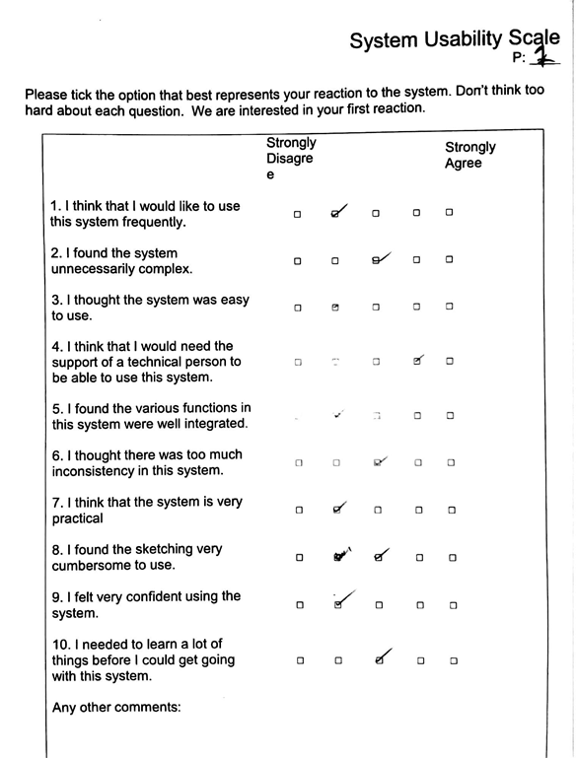

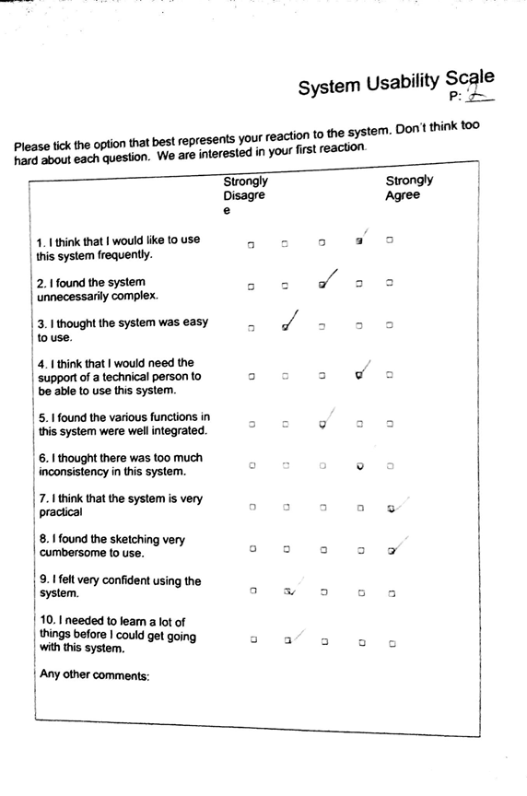

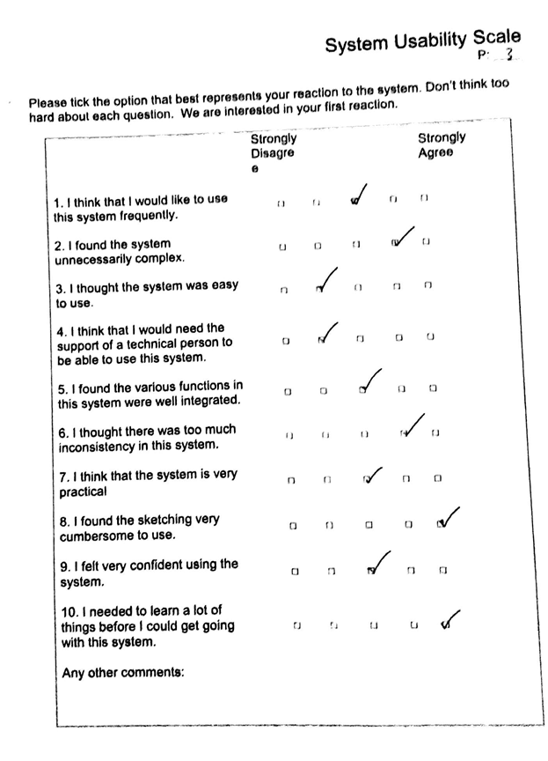

|  |  |
| --- | --- |
| Participant # | SUS score |
| 1 | 35 |
| 2 | 45 |
| 3 | 35 |

# 5) Discussion

**Effectiveness-** Each participant was expected to be able to complete all of the tasks in the evaluation. However, participant #2 was unable to complete Task #3, after 3 assists. The result dictates that 2 of the 3 participants reached the target, being able to complete all of the tasks with less than 3 assists per task.

**Efficiency-** Each participant was allocated a time of half an hour, and with each participant taking an average time of less than 10 minutes per task, the target was reached.

**Satisfaction-** None of the participants reached the target System Usability Score of 75. This was to be expected, as the evaluation were not done on the Smart Glasses. While the participants were able to trace on the screen, they found difficulty with sketching shapes and outlining, as they required assists to clear the trace.

# 6) Conclusion

The participants found 3 issues with the system. The most common issue being that the movements of their hand were inverted with that of the trace. The second issue was the cursor not being detected with the hand going off the view of the camera. The third issue was high sensitivity of the cursor, with the cursor drawing a small trace while the hand was static. The first two issues would be resolved with the use of the smart glass as the inverted movements work with the glasses, and the stable camera on the classes would always detect a cursor if your hands are in your vision. The issue with high sensitivity of the cursor could be fixed after optimizing the cursor detection. This usability evaluation successfully allowed us to recognize potential problems with the system, which might have been overlooked.